User Manual

For

Data Search Algorithms Complexity Comparison Program

**Function Description:**

This software is used to analyze the complexity analysis and compare different data structures for searching the same input data, and present the analysis results to users.

**Instructions of Operation Steps:**

Step 1: First, we run the program into the home page of the software (as shown in Figure 1). Then, we need to select at least one choice. For the above data structure, we use the drop-down selection box to select the data structure of different modes, We can choose the bounded/unbounded mode, and we can choose the ordered and unordered mode, we can choose the search implementation. Having selected at least one data structure we can then click confirm and Next to proceed to the next step. The above are the main functions. We can also click Menu --> Instructions to enter the software Instructions window to see how to use the software (as shown in Fig. 2).

Note: when the users click the "Confirm and Next" button, they must ensure that at least one data structure has been selected, otherwise a prompt will pop up, such as (as shown in Fig.3)

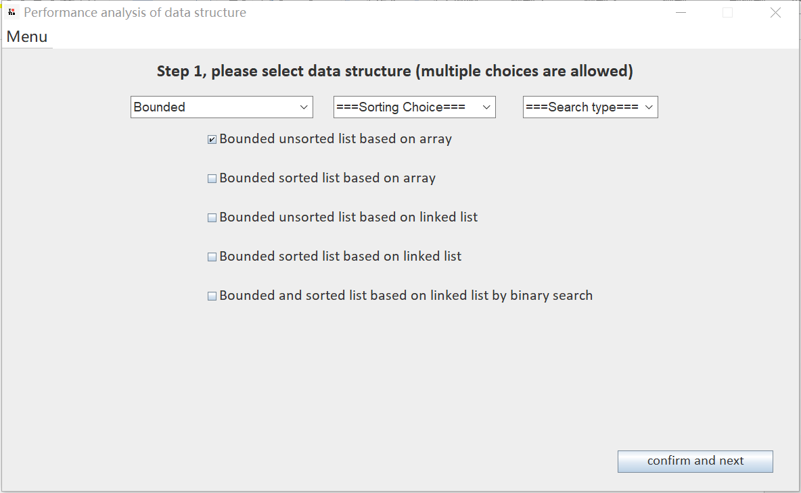

Fig. 1

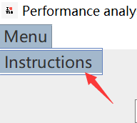

Fig. 2

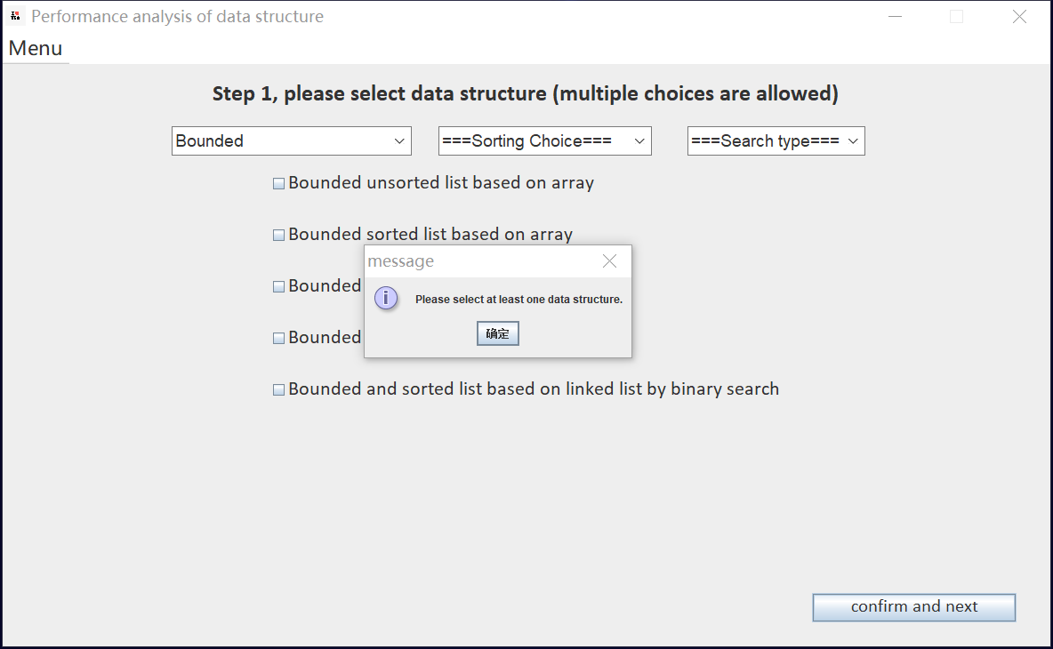

Fig.3

Step 2: In this step (Figure 4), users select different types of test data according to their own needs, including character type and Integer type, corresponding to buttons "String Type" and "Integer Type" respectively. To select character data, we need to click "Select a file" to open the window and select a file that contributes data. We need to enter the "Input a file separator" box in the "Input a file separator" box, for example ", ""," ", "|", etc. The user can determine this. If digital data is selected (Figure 5), we need to click the button "Generate 2000 Random Numbers" to make the system automatically Generate 2000 random test data within 2000.When the required data has been generated, we can click “confirm and next” to move to the next step.

Note: when the user clicks the "Confirm and Next" button, checks to see if the test data file has been selected, if the separator has been entered, or if 2,000 random integers have been generated, or if it has not, a prompt will pop up (as shown in Fig.6 and Fig.7)

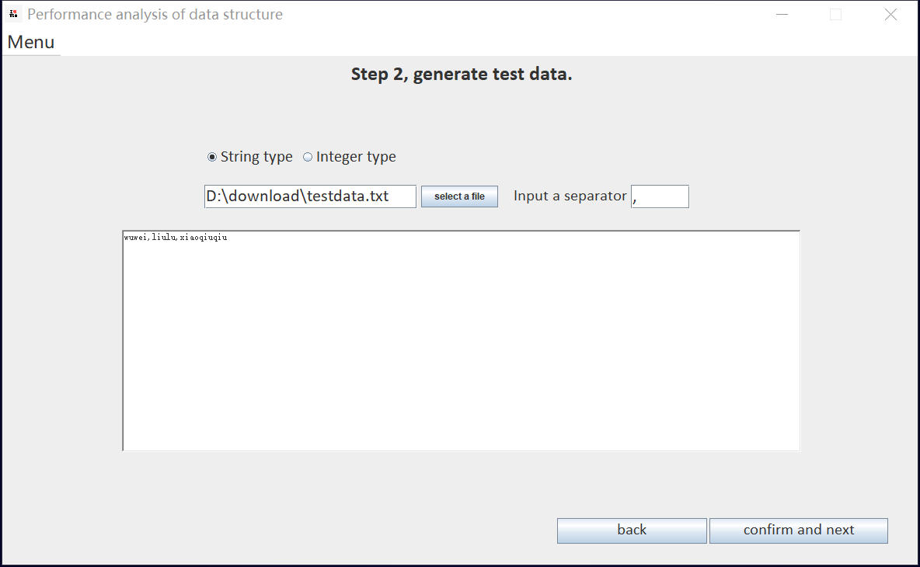

Fig. 4

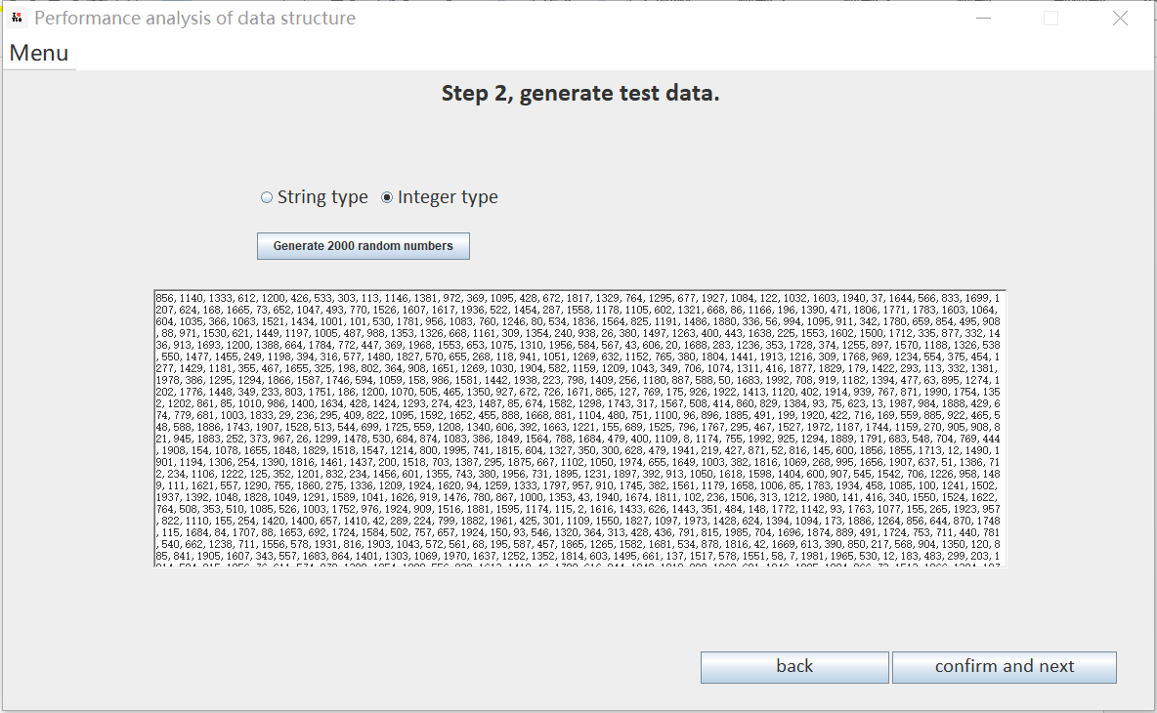

Fig. 5

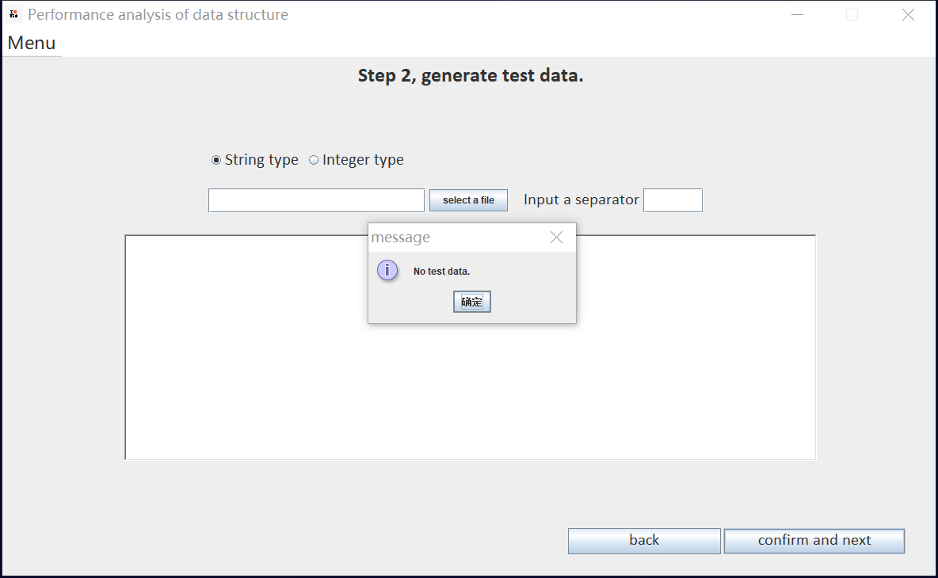

Fig. 6

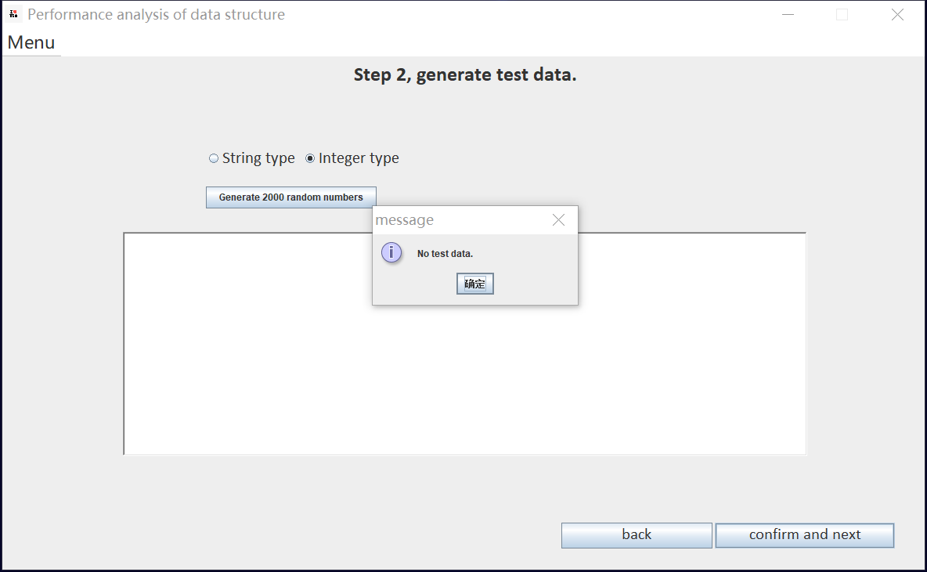

Fig.7

Step 3: This step (Figure 8) is used to start the search and generate the complexity analysis results. The user first needs to enter the data to be searched in the “Please enter a search target data” box, then click the button "Confirm and Start Analysis", and finally generate the execution results and search complexity analysis results in the blank text box.

Note: make sure you have entered the search target data before clicking the "Confirm and Analysis" button, and a prompt will pop up if you do not (as shown in Fig.9)

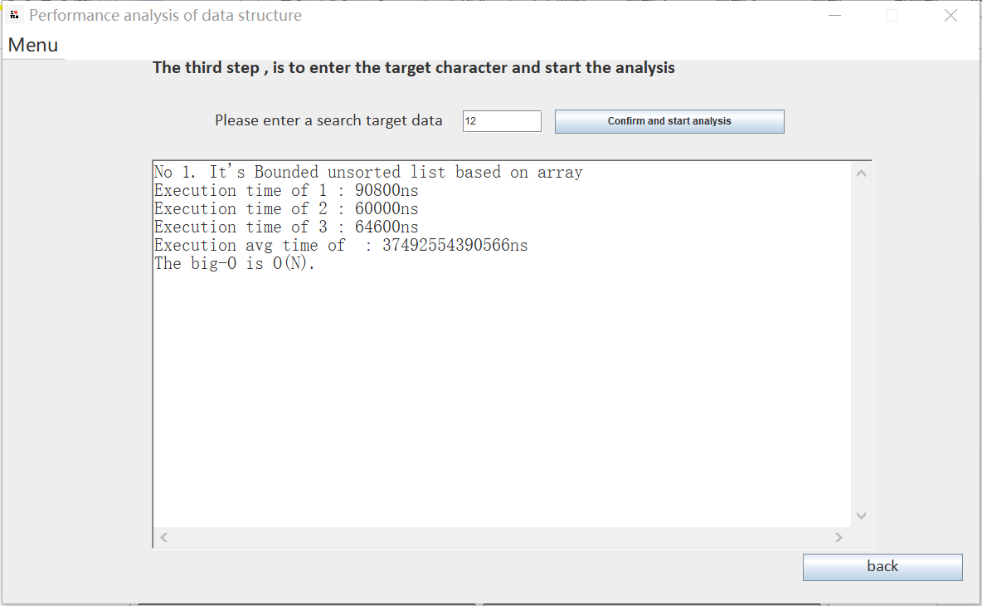

Fig. 8

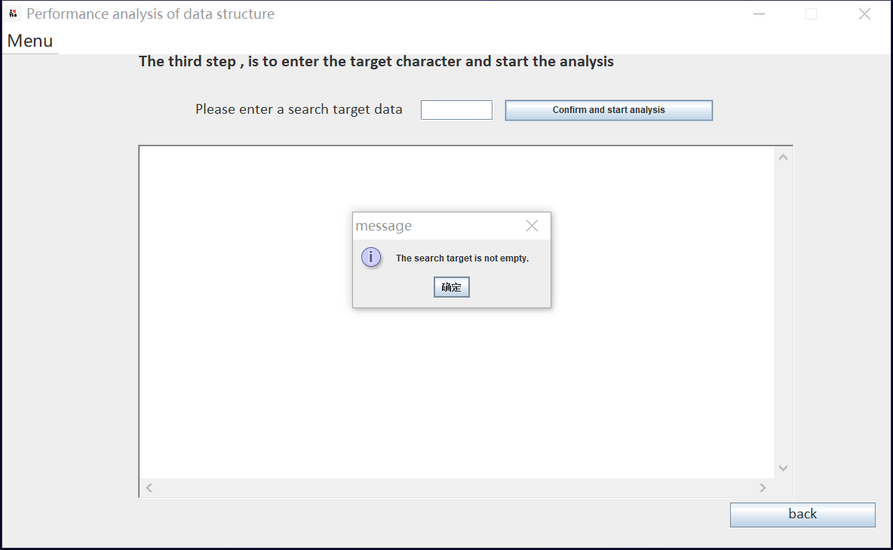

Fig.9